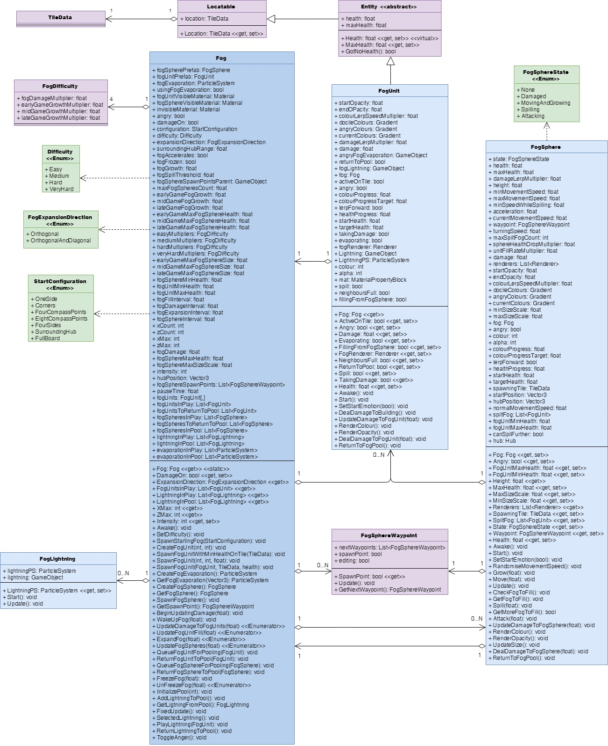Distinction Report UML Diagrams

Figure 1: the current structure of the fog-related classes.

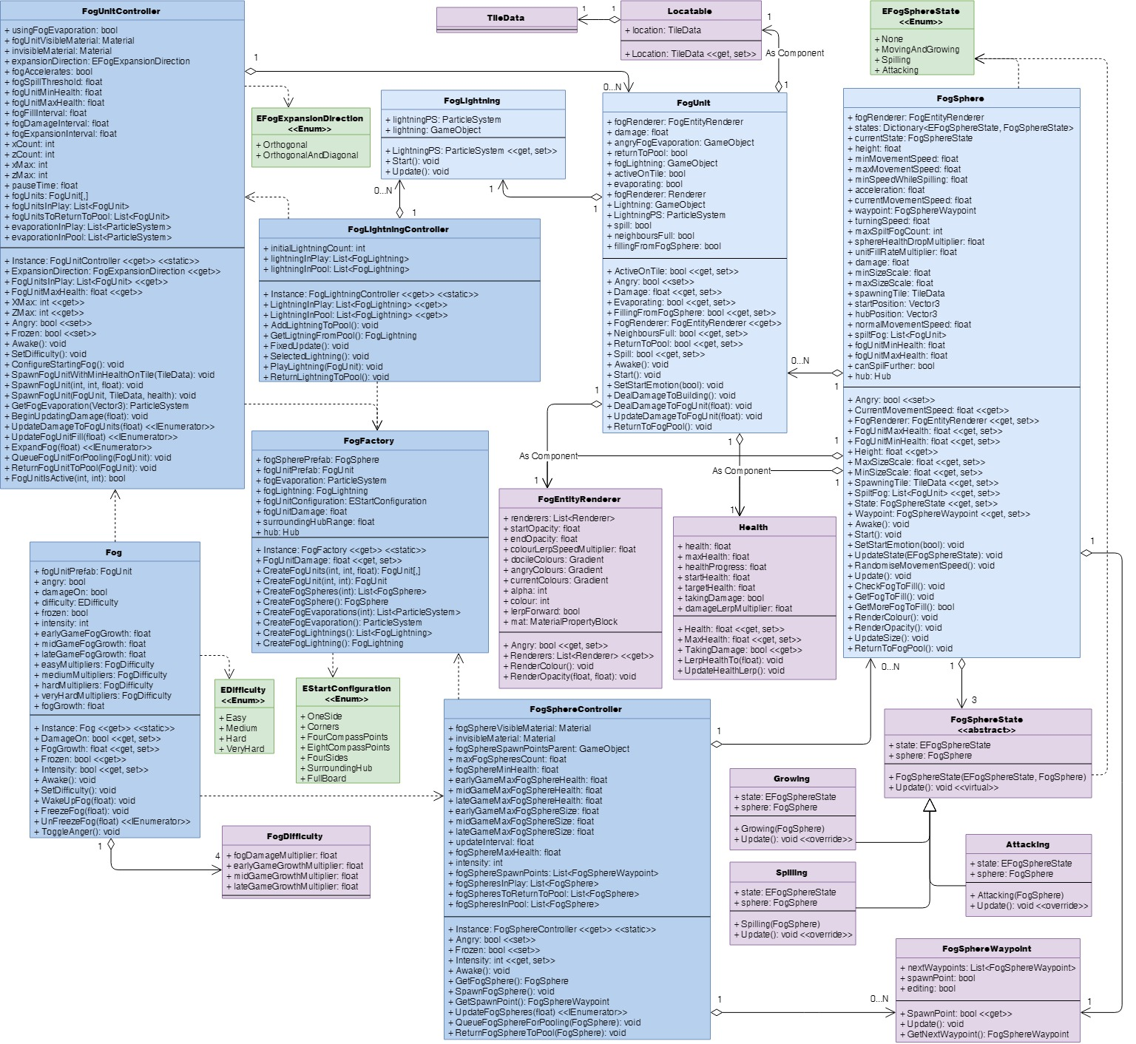

Figure 8: how I would restructure the fog classes to be more maintainable.

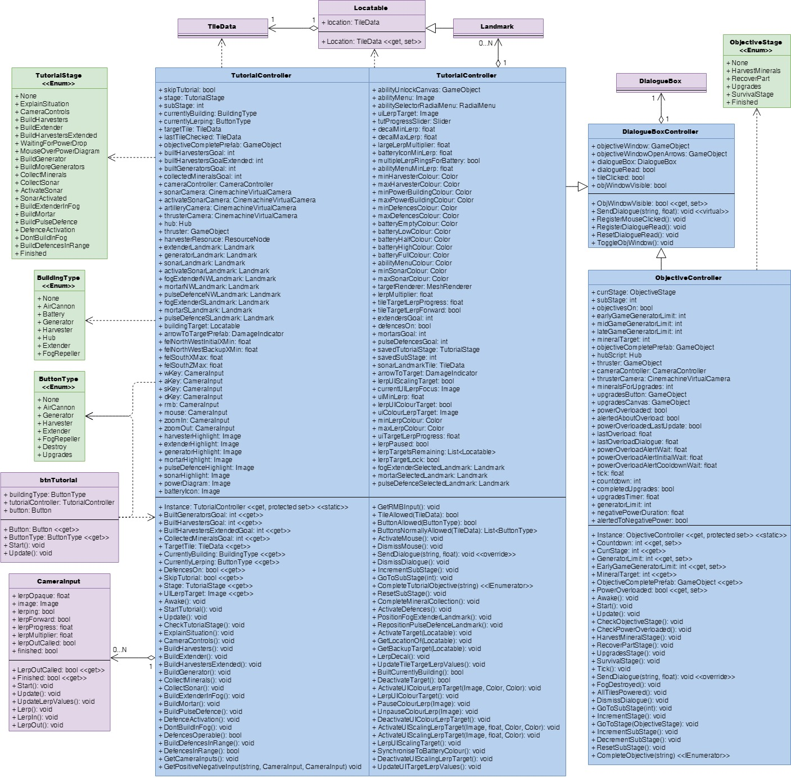

Figure 9: the current structure of the tutorial-related classes.

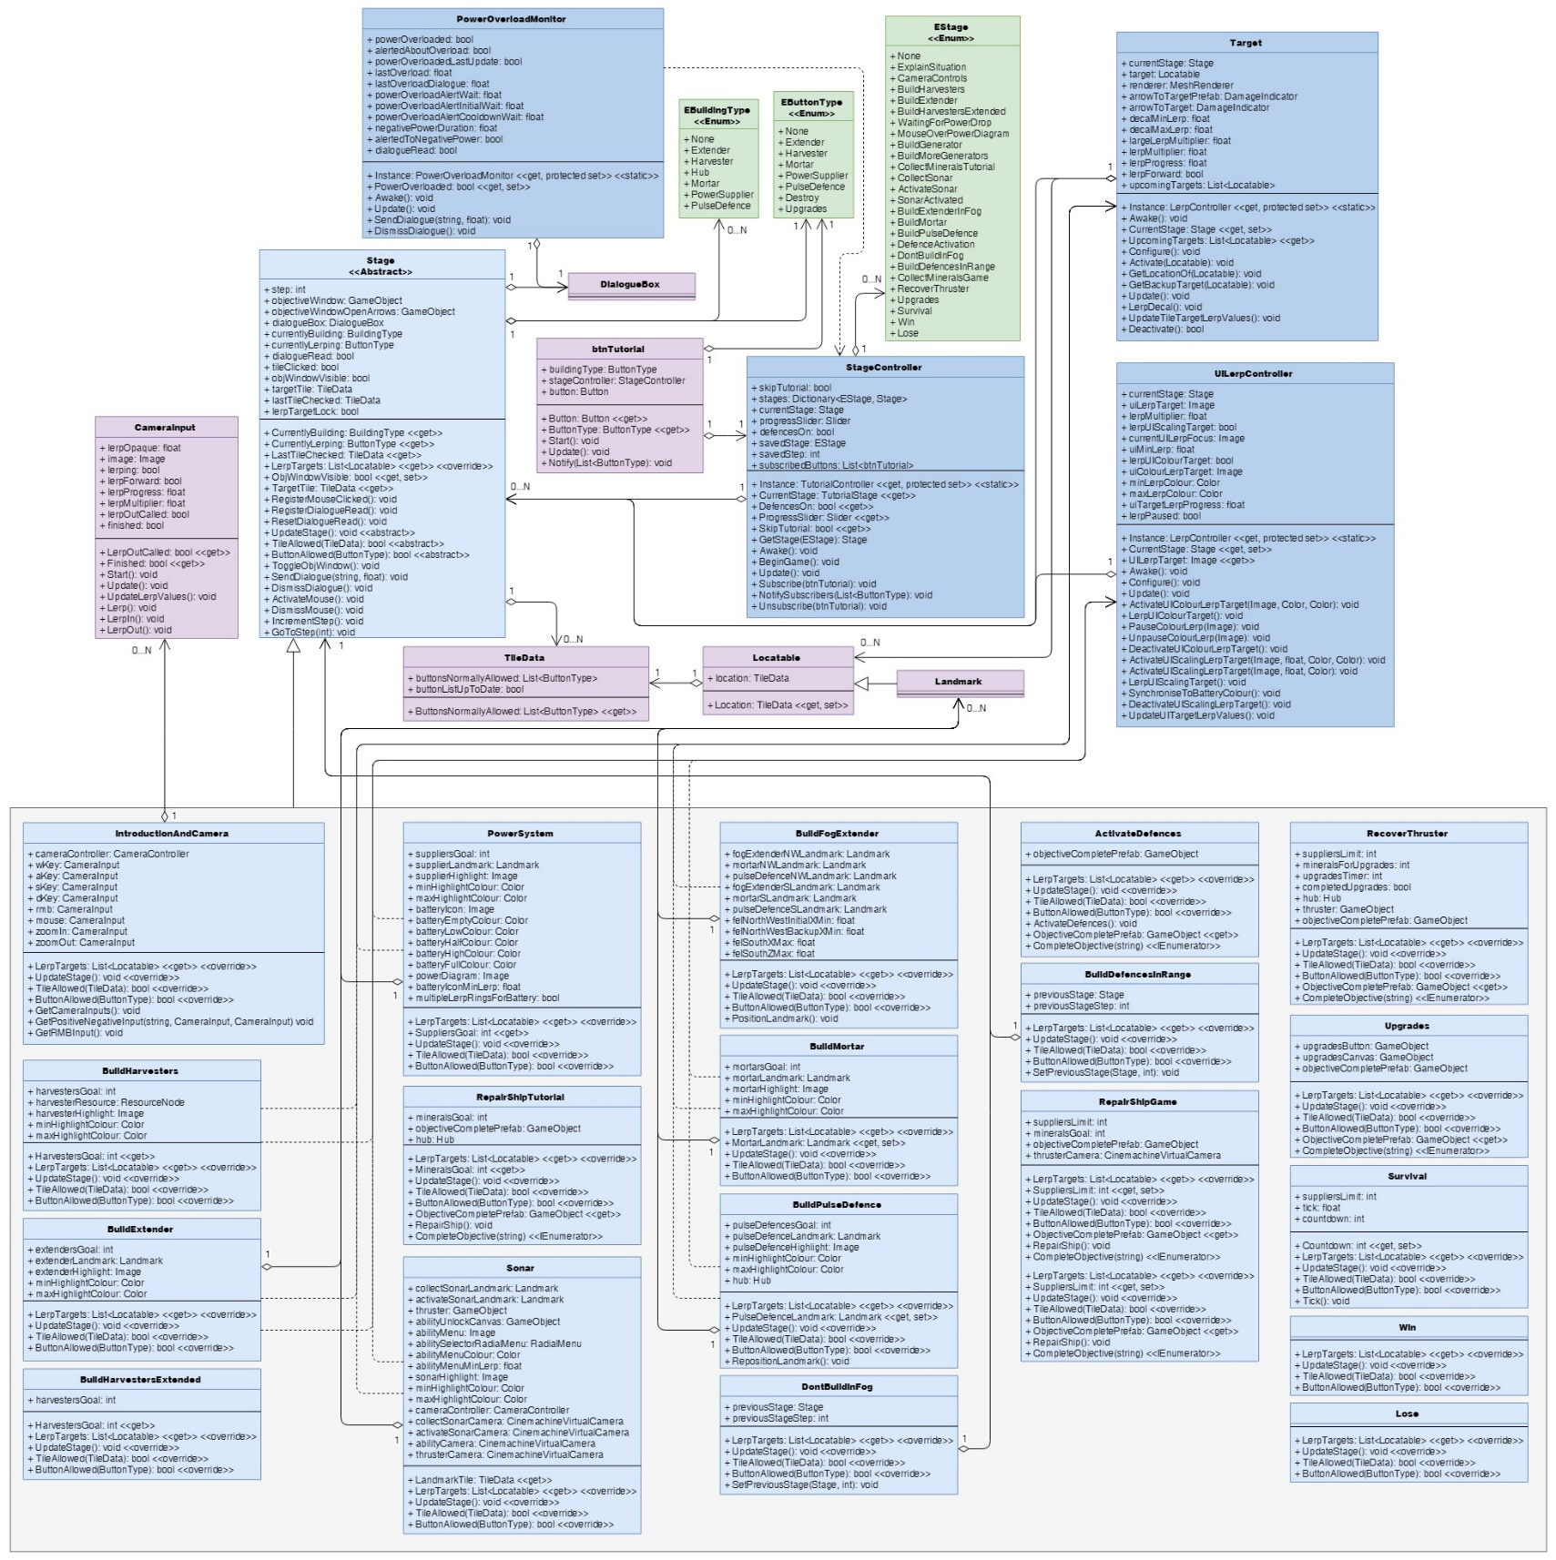

Figure 15: how I would restructure the objective related classes to be much shorter, more manageable, and more maintainable. Note: TileData is listed here as only having three members, but these are just the ones that would be redistributed to it upon a restructure; it has additional existing members irrelevant to the discussion of the objective classes that have not been listed for simplicity’s sake.

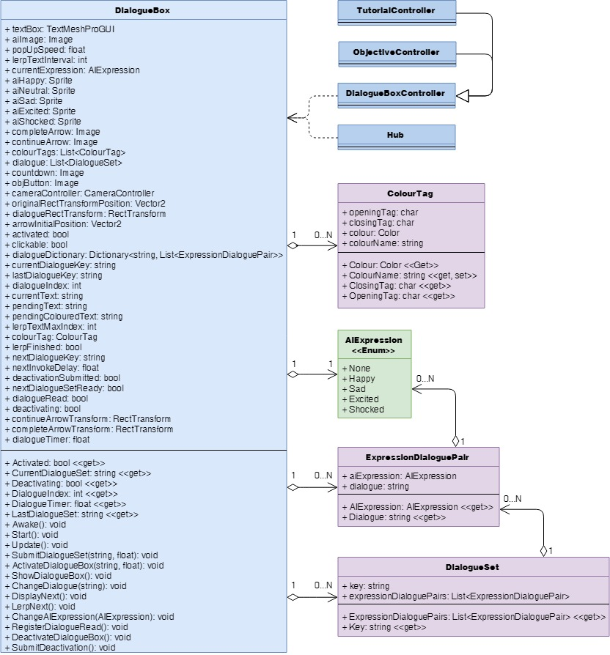

Figure 16: the current structure of DialogueBox and its related classes.

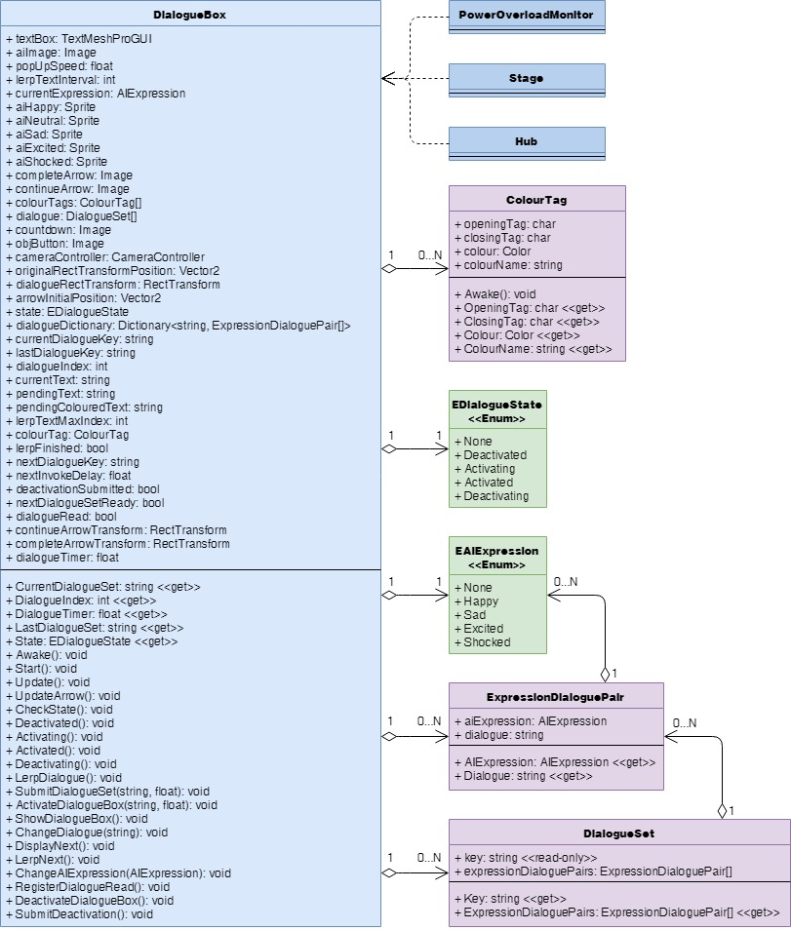

Figure 20: how I would restructure DialogueBox and its related classes to be more efficient and maintainable.